Android Communicator

Bhagirati Patil*, Chinmayi Dixit, Deepika B, Abhishek Sinha

*BVB College of Engineering & Technology, Hubli – 580031(India)*

*Corresponding Author(bhagyacp@gmail.com)

*Abstract –***In this project, a P2P Communication Framework is created for the android platform. It uses standard multicasting facilities to collaborate multiple android devices, share content spontaneously, and interact with multiple devices at once using a Wi-Fi interface. Android devices with Wi-Fi connectivity can use any public domain or authenticated Wi-Fi network to transfer files or communicate with multiple devices faster. Representative applications of the project include group chatting; camera video streaming and file transfer within structured environments. The basic skills required to develop the project are multicasting, socket programming and Android networking.**

***Keywords***—**Android, P2P, Multicast, Socket Programming, Communication**

I. INTRODUCTION

In the age of technology and gadgets, information sharing is a growing trend. The portable devices that have the capability to carry a large amount of data have made it easy to disseminate knowledge and data. In structured environments like diners, offices etc., it is comfortable to have an easy way of circulating messages and files and communicate with each other effectively. Use of a point-to-point network would make this a reality.

In networking, the Point-to-Point Protocol, or PPP is a data-link protocol commonly used in establishing a direct connection between two networking nodes []. It can provide connection authentication, transmission encryption privacy, and compression. Different configuration options provided by P2P protocols are authentication, compression, error detection and multilink []. When a message is being exchanged using the protocol, it is made sure to be authentic using the Password Authentication Protocol [PAP] or Challenge Handshake Authentication Protocol [CHAP]. To make the data transfer efficient, the data can be compressed at the source and after reaching the destination, be decompressed. P2P protocol provides an error checking mechanism to make sure the frames are transferred correctly. Also, if the load is high in the link, it is a better option to provide multiple links that help in load balancing.

Another useful concept widely applied in networking is multicasting. Multicasting is the sending of a single message or file to multiple destinations. This is different from sending the file or message multiple times to all the destinations individually, by the fact that there is only a single packet, which is sent to all destinations instead of multiple packets of same message. It is the task of the routers to track subscriptions and to create copies only on an as-needed basis. Multicasting includes subscribers and routers as its main players; subscribers being on the receiving and sending ends and routers responsible for the transfer. Each router keeps track of subscribers to a given stream and forwards the relevant information to the next router out for that stream. Transferring a same message to multiple destinations gives rise to group creations and management. Multicasting protocols give a noteworthy solution to the group communication issues.

Use of networking in android devices is an emerging field. There aren’t many readily made solutions to the wide demands from android devices toward this end. Android devices contain Apache HttpClient Library, which is a preferred way of performing network operations in android. Android programming tools also include functionalities such as the java networking API –which internally uses Apache library. Also, it provides the basics of Berkley socket programming interface. This interface mainly consists of sockets intended for intercommunication of computers or devices over a computer network []. It has the capability to work with different operating systems and environments. An android socket-programming interface requires the application of a chosen protocol by the programmers themselves.

This paper explains a project undertaken by the students of BVB college of Engineering and Technology, Hubli, as a major project for the stream of Computer Science and Engineering. It provides the problem definition in section 2. In section 3 the software requirements are depicted and in section 4 the design details are handled. The paper concludes with the project employment level quoted. The constraints of the project are that there should be a Wi-Fi environment available and the device should employ android operating system.

II. PROBLEM DEFINITION

“To build A P2P communication framework for android mobile platform”

*A. Objectives*

* To create P2P communication framework for android devices.
* To use Wi-Fi interface for the communication
* To implement an application using standard multicasting facilities.

*B. Applications Of the System*

* Sharing of files -images, videos etc., among multiple phones using WIFI.
* Communicating with multiple phones at once

*C. Scope of Project*

This app will be used on the Android mobile OS, and is primarily intended to allow users to utilize Wi-Fi to set up spontaneous communication end-points employing Multicasting. The main benefit of developing this app for the Android phone is content sharing within structured environments like offices, dining rooms, hotels, conference rooms, and cafeteria.

*D. Product Perspective*

This product is a new, self-contained product. And it is to build an Android based application that will provide the users with reliable software, which creates an efficient, and simple communication point-to-point framework.

*E. User Classes and Characteristics*

* The most important users for the software will be the general public in offices, dining rooms, hotels, conference rooms and cafeteria.
* Since the software will be available to the public in Android market place, and on the company website, anyone with an Android phone can be a potential user.

*F. Operating Environment*

*Hardware requirements*

Device: Android enabled smart phone.

System: Desktop (min 512MB RAM & 40GB Hard Disk).

Mobile RAM: 279 MB or more.

Modem: WIFI 802.11IEEE Wireless

Ethernet

*Software requirements*

Operating system: Windows XP and Android

Software: Android SDK 2.2 or above

IDE: Helios Eclipse version 3.6.1

*G. Assumptions and dependencies*

Assumptions:

* All Android phones are able to run the software correctly.
* Installing, Removing and Updating software onto the Android O/S is easily achievable.
* Android provides application needs such as simple implementation into a graphical user interface.
* Android users will have phones using a touch screen facility.

*H. Dependencies*

System shall be dependent on a machine running with java plug-in.

The system shall implement an android operating system.

A Wi-Fi network will be available during the use.

III. SRS

*A. Functional Requirements*

* Initialization and termination Process

Through this process user shall be able to start and establish a group creation for sharing

Functionality:

System should allow user to

* Detect devices connected to the WI-FI.
* Send a request to join a group.
* Create a group with 2 or more devices.
* Save group details for further use.
* Create temporary groups spontaneously.
* Disconnect from group at will.
* Connection process

Through this process user shall be able to request in an already established connection.

System should allow users to

* Select which group to connect to.
* Save group details for further use.
* Choose which WIFI network to connect to
* Sharing process

System should allow users to

* Send files to other devices on the groups.
* Cancel a transaction in between.
* Send notifications after a file was sent or if there were any errors.
* Send ping messages to all devices in the selected group.

A device on the group should be able to access shared files on other devices on the group

* Camera Video streaming process

System should allow users to

* Send saved captured video stream to the selected device or the group.

*B. Nonfunctional Requirements*

*Performance requirements*

* Performance intensive operations like Detection of devices, sending requests, Creation of groups with available phones during initiation phase will take less than 10 sec 97% of times.

*Security Requirements*

The following *is a* list of security requirements that indicate how the system shall protect itself and its sensitive data and communications from accidental, malicious, or unauthorized access, use, modification, or destruction

* The system shall not allow addresses of unauthorized devices to be stored into the system’s repository.
* The system shall not permit unauthorized devices to access or participate in any activity started by the device-concerned user.

The system shall not allow confidential data stored in the system’s database to be accessed, whether directly or indirectly, by client (mobile) users.

IV. SDD

1. *Common scenario with Use cases descriptions*

The following figures depict different scenarios that can commonly happen in the application in form of use cases and with description alongside them.

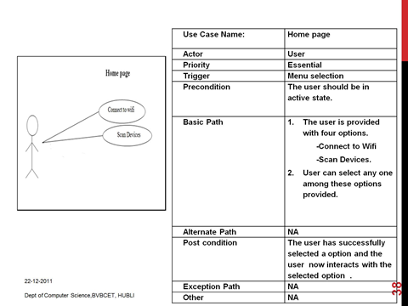

Fig 1. Use case 1 – Home page

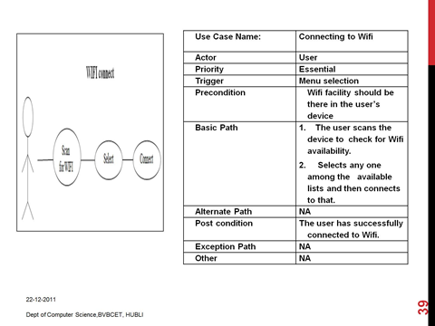

Fig 2. Use case 2 – Wi-Fi connect

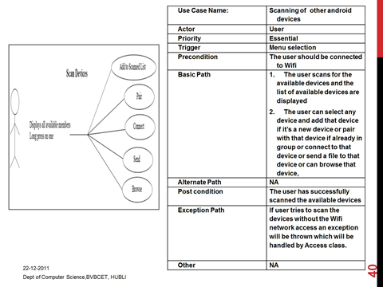

Fig 3. Use case 3 – Scan Devices

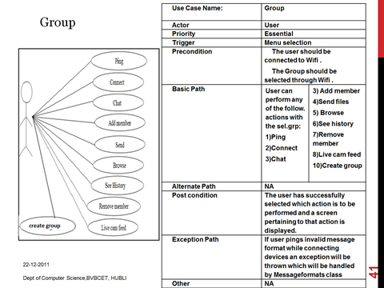

Fig 4. Use case 4 – Group

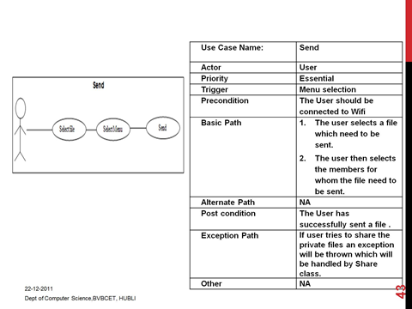

Fig 5. Use case 5 – Send

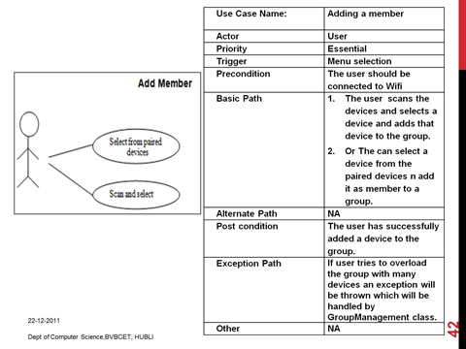

Fig 6. Use case 6 – Add member

*B. USER INTERFACES*

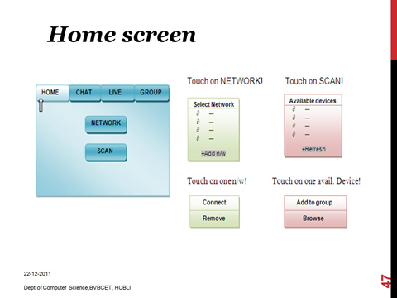

FIG 7. User Interface Home

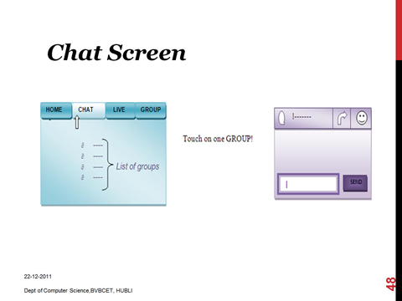

FIG 8. User Interface Chat

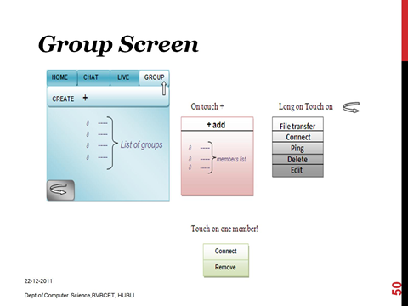

FIG 9. User Interface Groups

The above diagrams depict how the user interfaces look like roughly. The navigation between pages and types of events are shown in figures 7, 8 and 9.

*C. Deployment diagram*

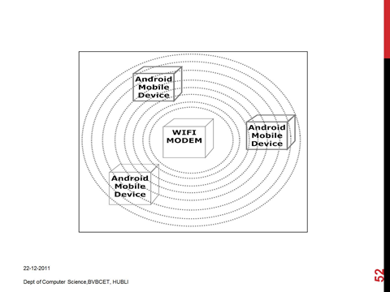

Fig 10. Deployment

The above diagram shows the environment in which the users will be using the system. The necessity is a Wi-Fi modem, through whose connectivity are the devices connected to each other.

*D. Design decisions*

* The product development uses the iterative model of software development, which facilitates to develop prototypes in each iteration and get user feedback, which is necessary since a similar system doesn’t exist.
* Language used to develop this application is java in order to use object oriented methodologies.
* Android SDK is used to design front end.
* Software used for the project development is open source.

V. CONCLUSIONS

The paper illustrates a project developed to provide point-to-point communication for android mobile platform. It discusses the problem definition and need for an interface to share data spontaneously over a fast network between multiple devices. It further illustrates the SRS with functional and non-functional requirements of the application and the Software Design Document for the app with use cases and user interfaces. The app has been successfully developed and is working to the expectations.

VI. FUTURE WORK

The project considers only 5 devices in a group. This can be extended for more devices as per the requirements. As the speed provided by the app is real time, this extension seems plausible. The app can also be implemented on multiple mobile OS like iOS and windows. The app is interacting with only one group at a time. This can further be modified to include multiple group transactions individually simultaneously.

V. REFERENCES

[i] Robosoft Technologies Pvt. Ltd, *Suggested,* (2011 Aug).

[ii] developers.android.com